Week 01

Question 1:

Problem Statement :

This is a simple challenge to help you practice printing to stdout. We're starting out by printing the most famous computing phrase of all time! In the editor below, use either printf or cout to print the string Hello, World! to stdout.

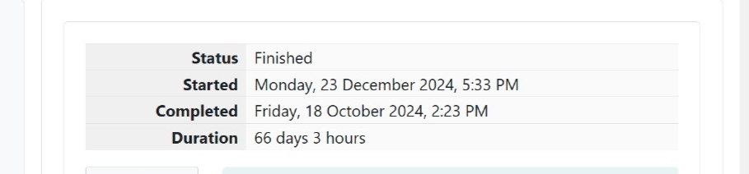

Program:

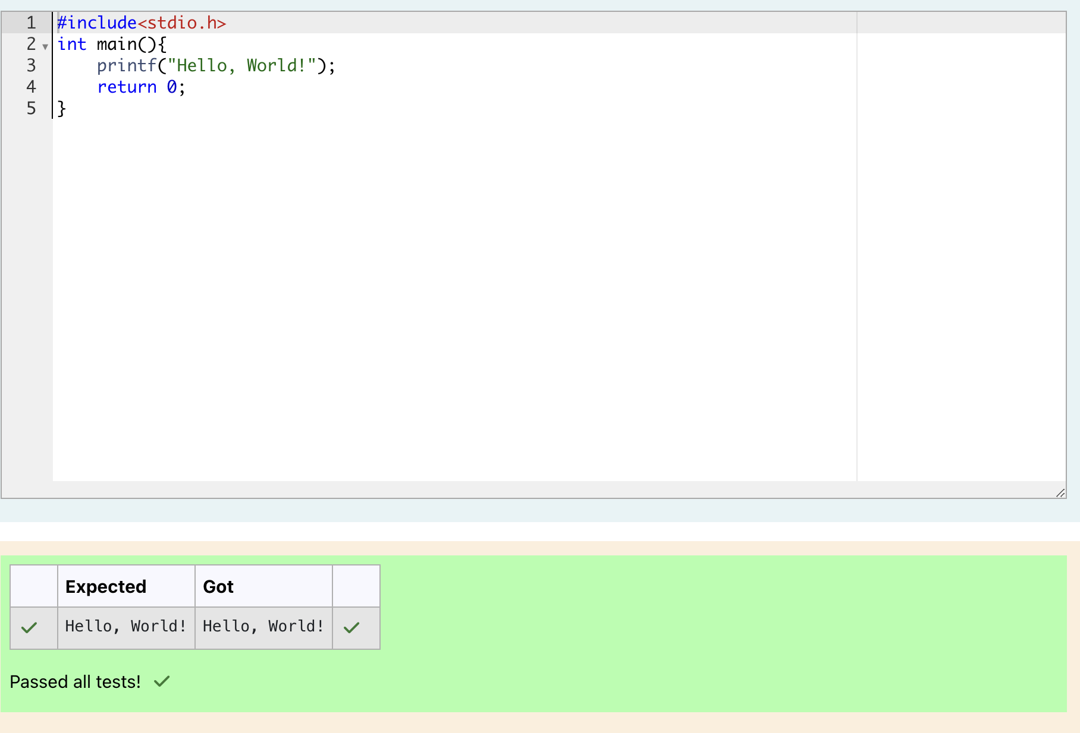

output: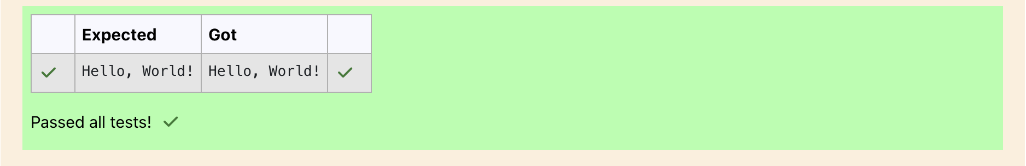

Question 2:

Problem Statement:

This challenge will help you to learn how to take a character, a string and a sentence as input in C. To take a single character ch as input, you can use scanf("%c", &ch); and printf("%c", ch) writes a character specified by the argument char to stdout:

char ch;

scanf("%c", &ch);

printf("%c", ch);

Program:

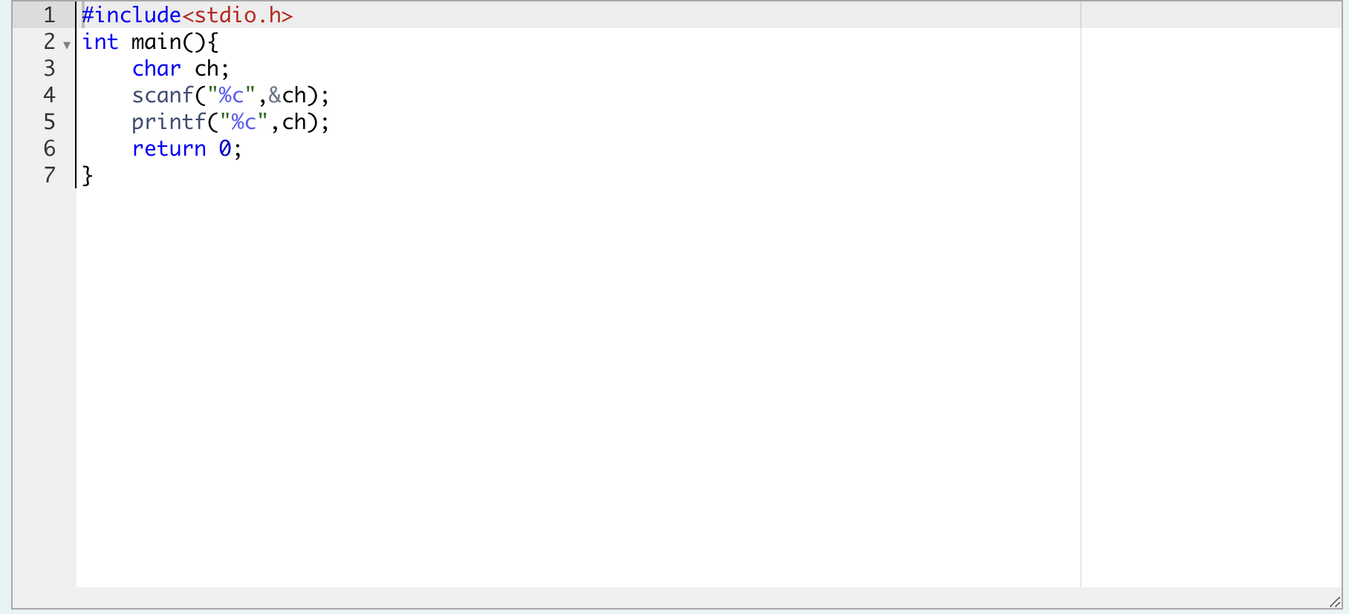

Output:

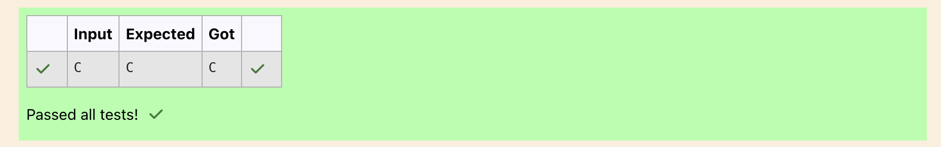

Question 3:

Problem Statement:

The fundamental data types in c are int, float and char. Today, we're discussing int and float data types. The printf() function prints the given statement to the console. The syntax is printf("format string",argument_list);. In the function, if we are using an integer, character, string or float as argument, then in the format string we have to write %d (integer), %c (character), %s (string), %f (float) respectively. The scanf() function reads the input data from the console. The syntax is scanf("format string",argument_list);. For ex: The scanf("%d",&number) statement reads integer number from the console and stores the given value in variable number. To input two integers separated by a space on a single line, the command is scanf("%d %d", &n, &m), where n and m are the two integers.

Program:

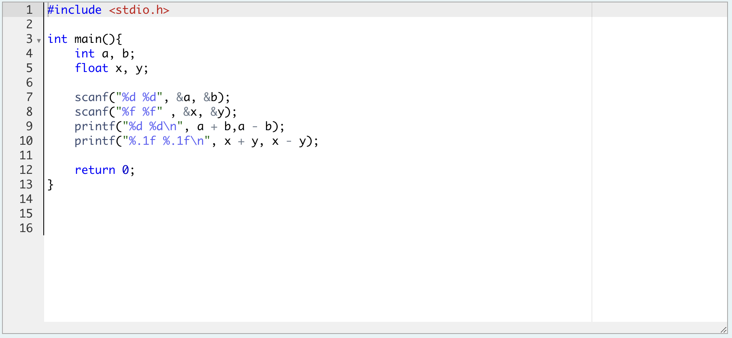

Output:

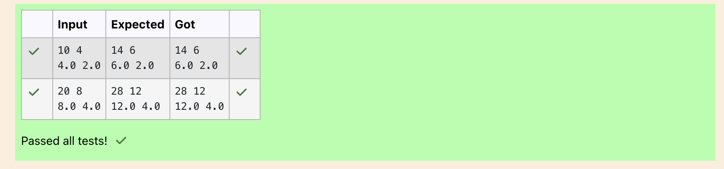

Question 4:

Problem Statement:

Write a program to input a name (as a single character) and marks of three tests as m1, m2, and m3 of a student considering all the three marks have been given in integer format. Now, you need to calculate the average of the given marks and print it along with the name as mentioned in the output format section. All the test marks are in integers and hence calculate the average in integer as well. That is, you need to print the integer part of the average only and neglect the decimal part.

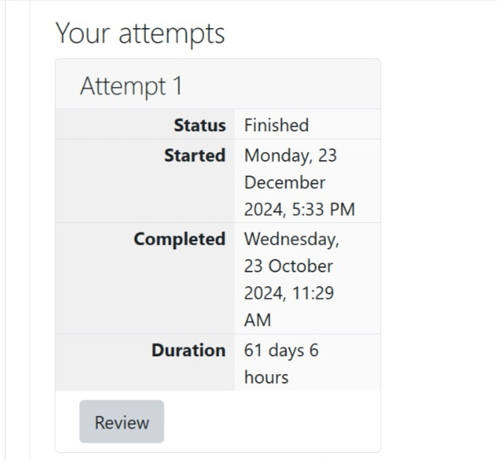

Program:

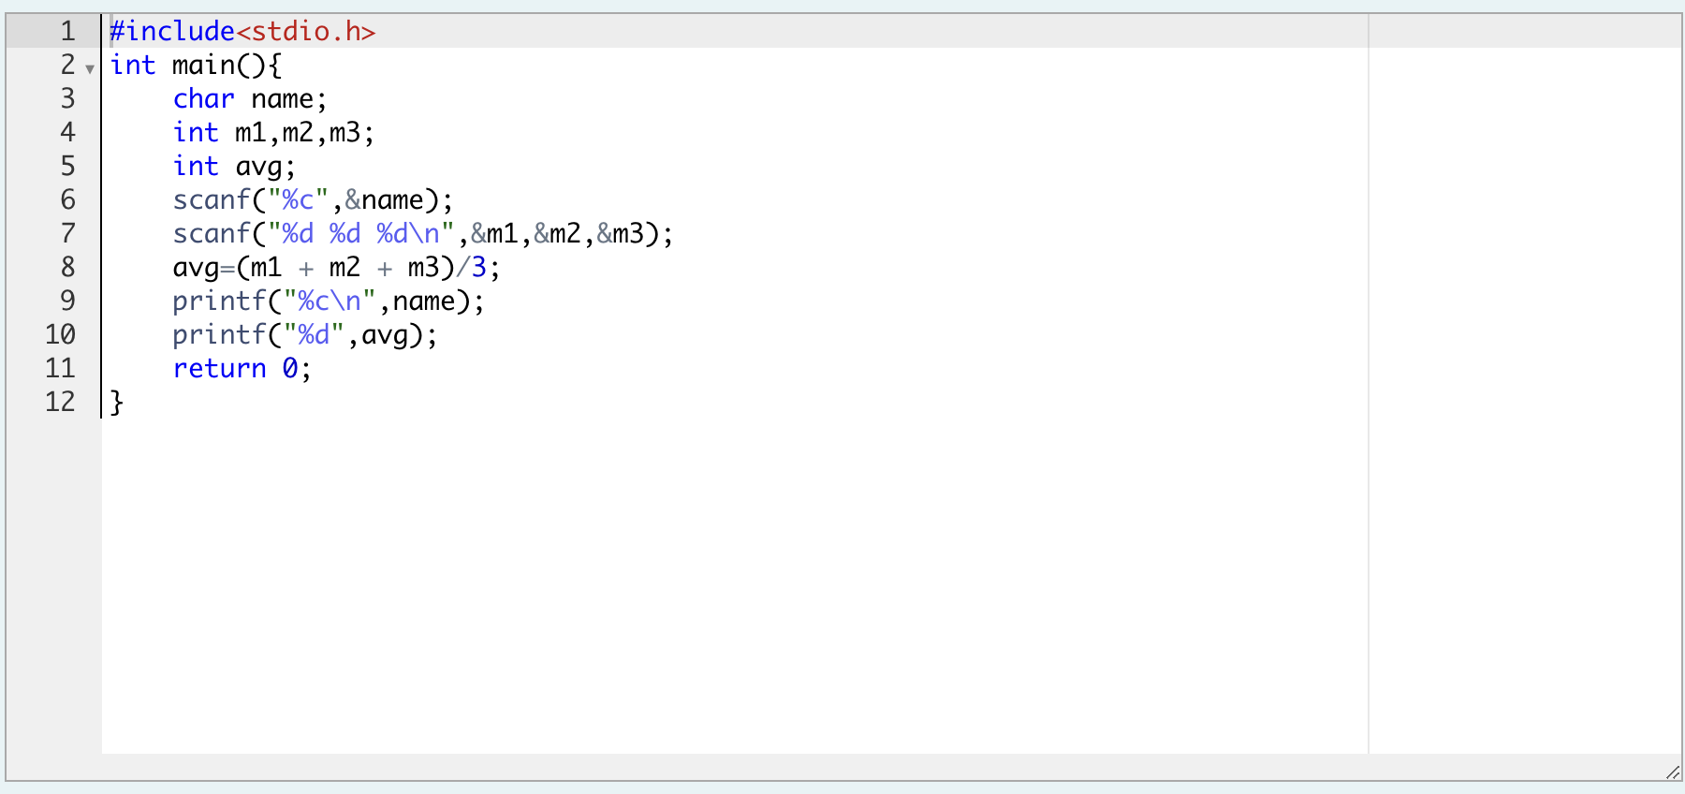

Output:

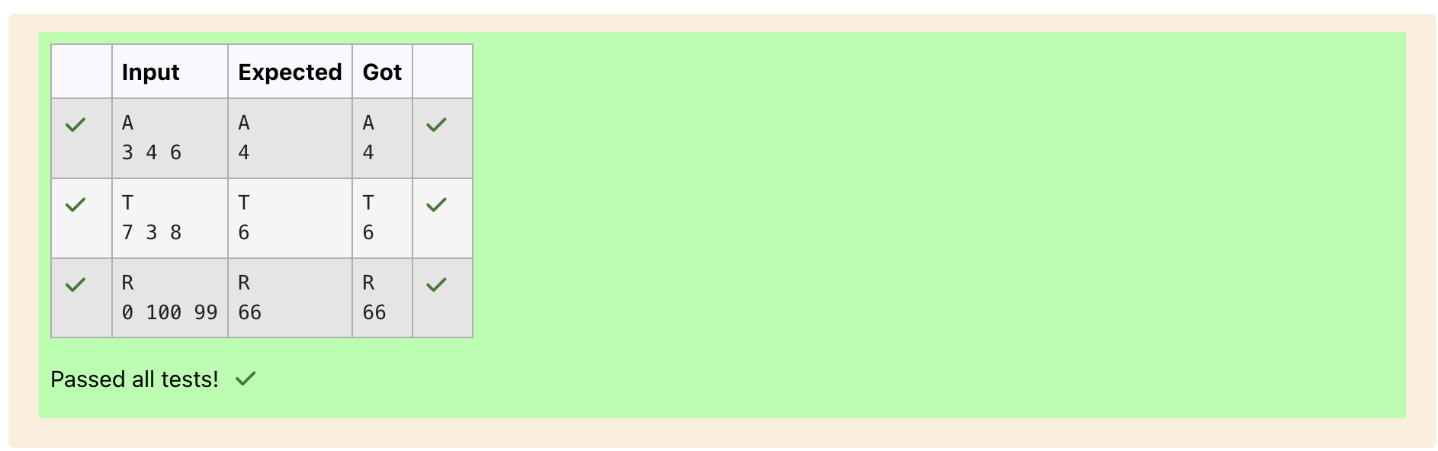Question 5:

Problem Statement:

Some C data types, their format specifiers, and their most common bit widths are as follows:

• Int ("%d"): 32 Bit integer

• Long ("%ld"): 64 bit integer

• Char ("%c"): Character type

• Float ("%f"): 32 bit real value

• Double ("%lf"): 64 bit real value

Program:

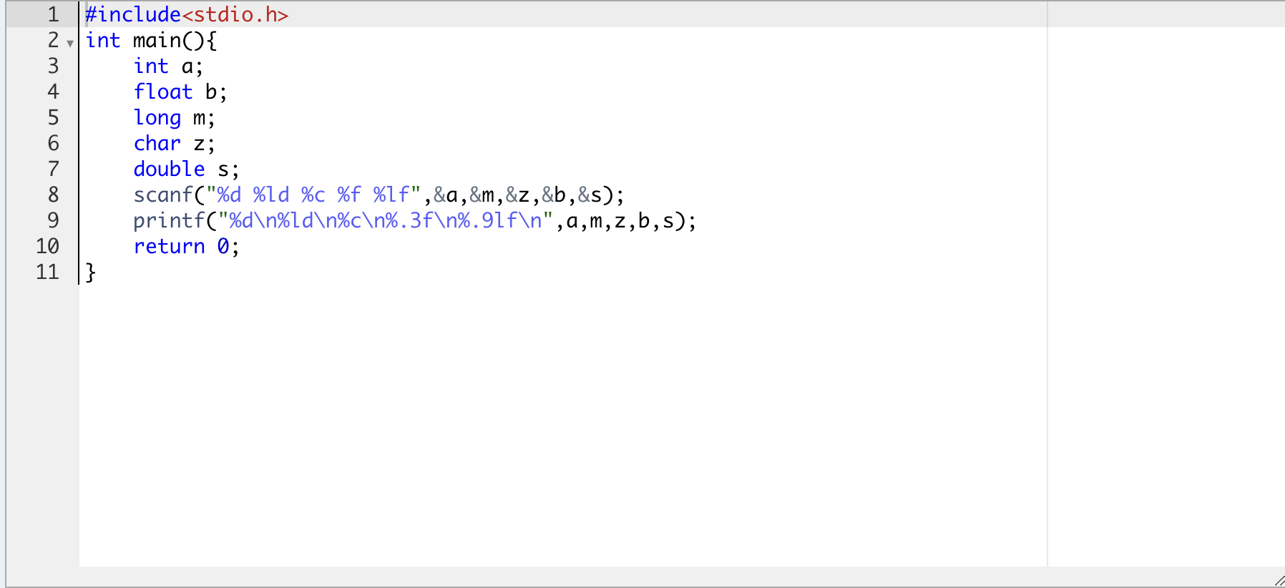

Output:

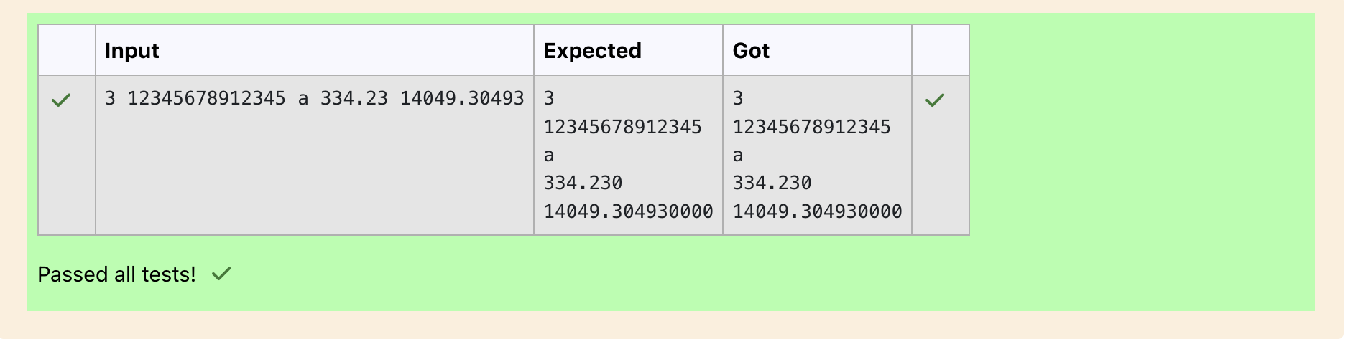

Question 6:

Problem Statement: Write a program to print the ASCII value and the two adjacent characters of the given character.

Program:

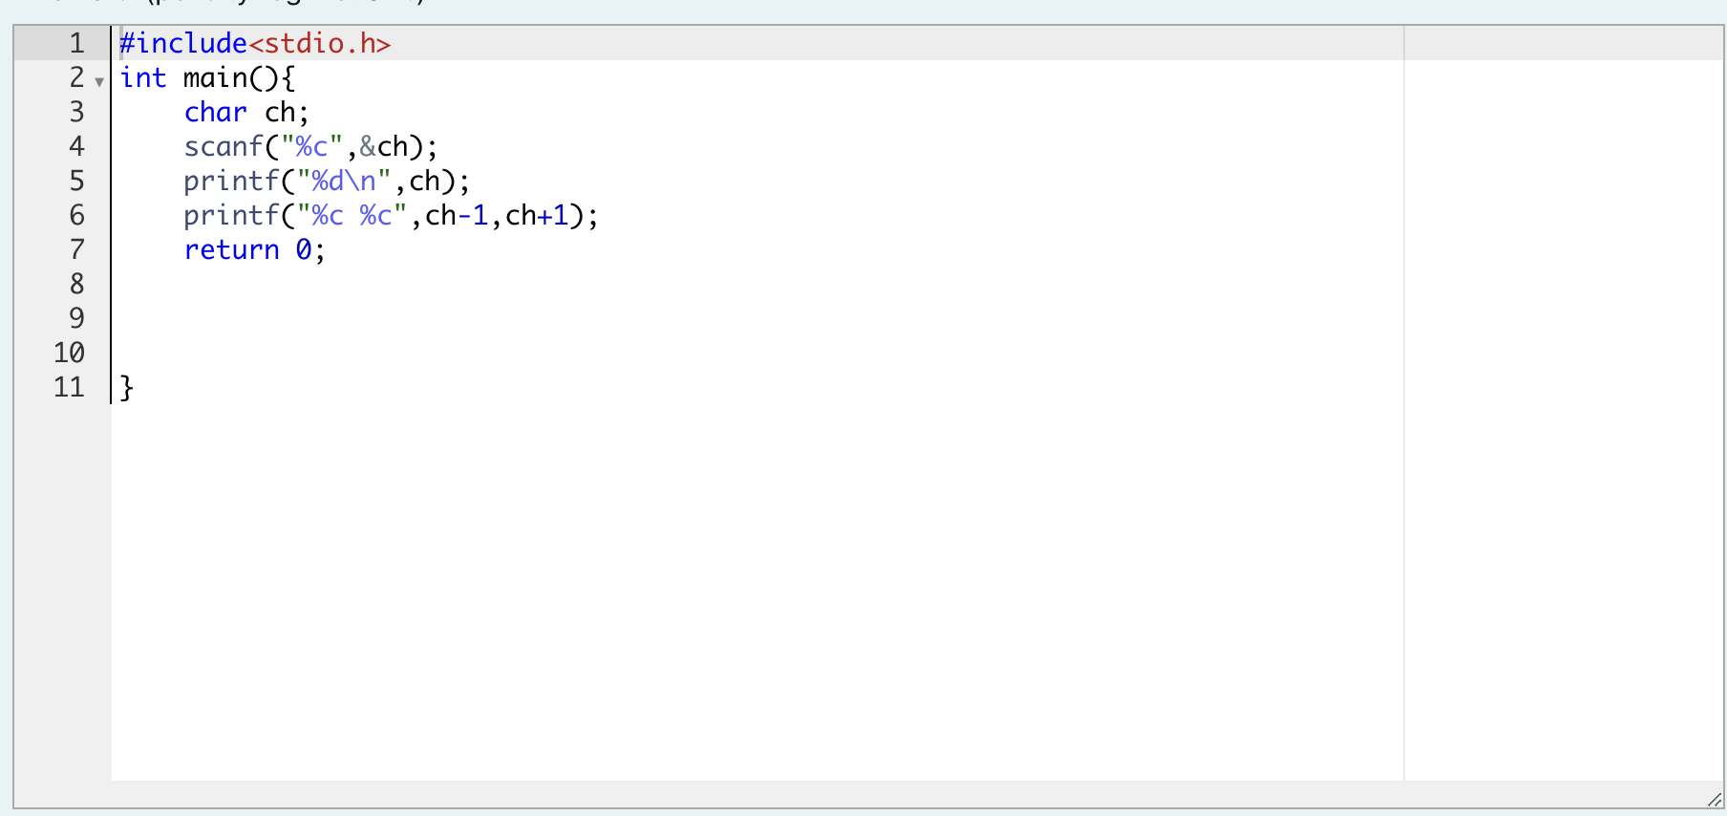

output:

